Authentication (OpenID)

Summary
The purpose of this exercise is to understand a single sign-on mechanism for web sites, OpenID, and then comment on its usefulness and security. Read about OpenID in the Stallings book, the OpenID website http://openid.net/connect/faq/ or the Google Identity Platform: https://developers.google.com/identity/protocols/OpenIDConnect.
For this assignment, you will need an account from at least one of the following: Google, Facebook, Twitter(X), or GitHub. You will interact with a test site I have created for this lab: https://kengraf-auth2.firebaseapp.com/
You will complete the following actions:
- Connect with your social network identity
- Analyze the access token
- Revoke access

Tools/Resources
Websites:
https://kengraf-auth2.firebaseapp.com/
https://jwt.io

Walkthrough
- Install
- A
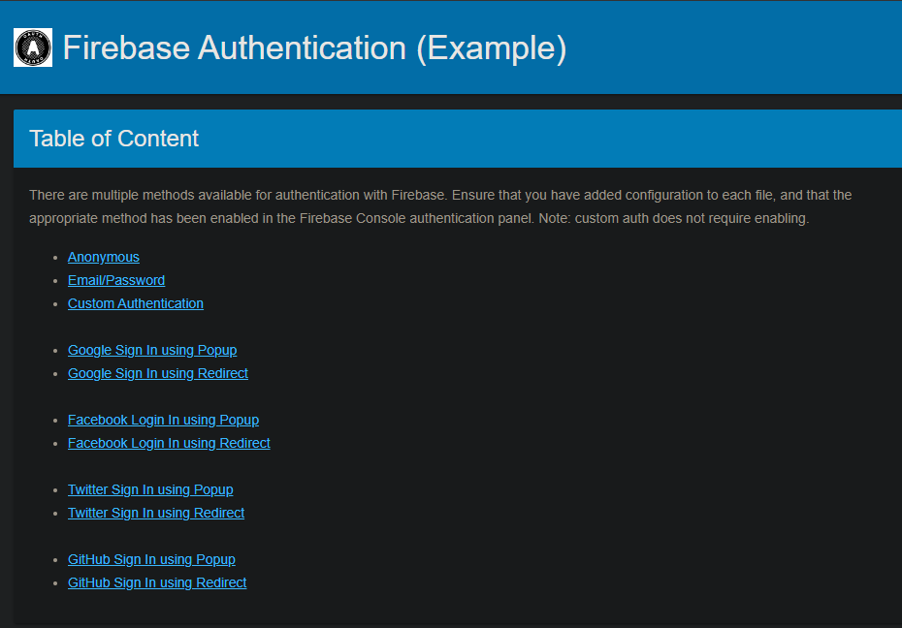
I used Google with popup (pick yours)
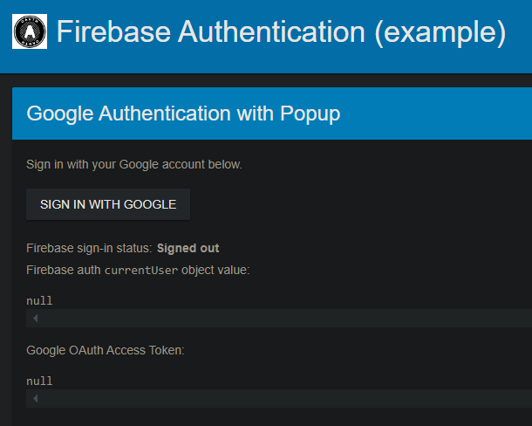
Result
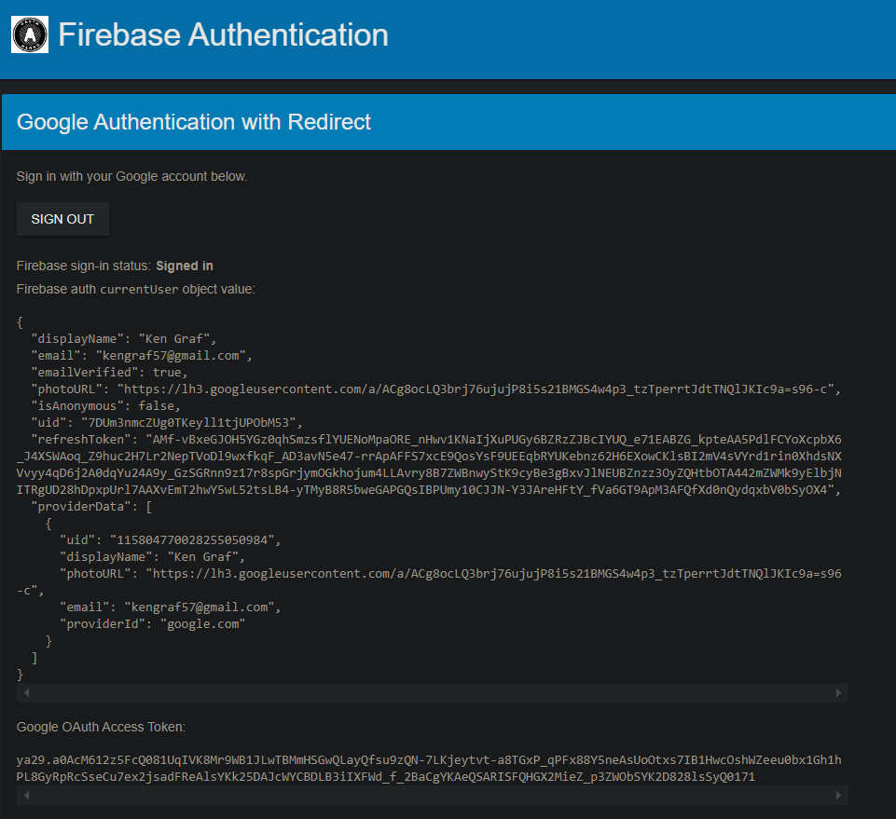
The access token is managed as a locally stored value and returned as an authentication token.
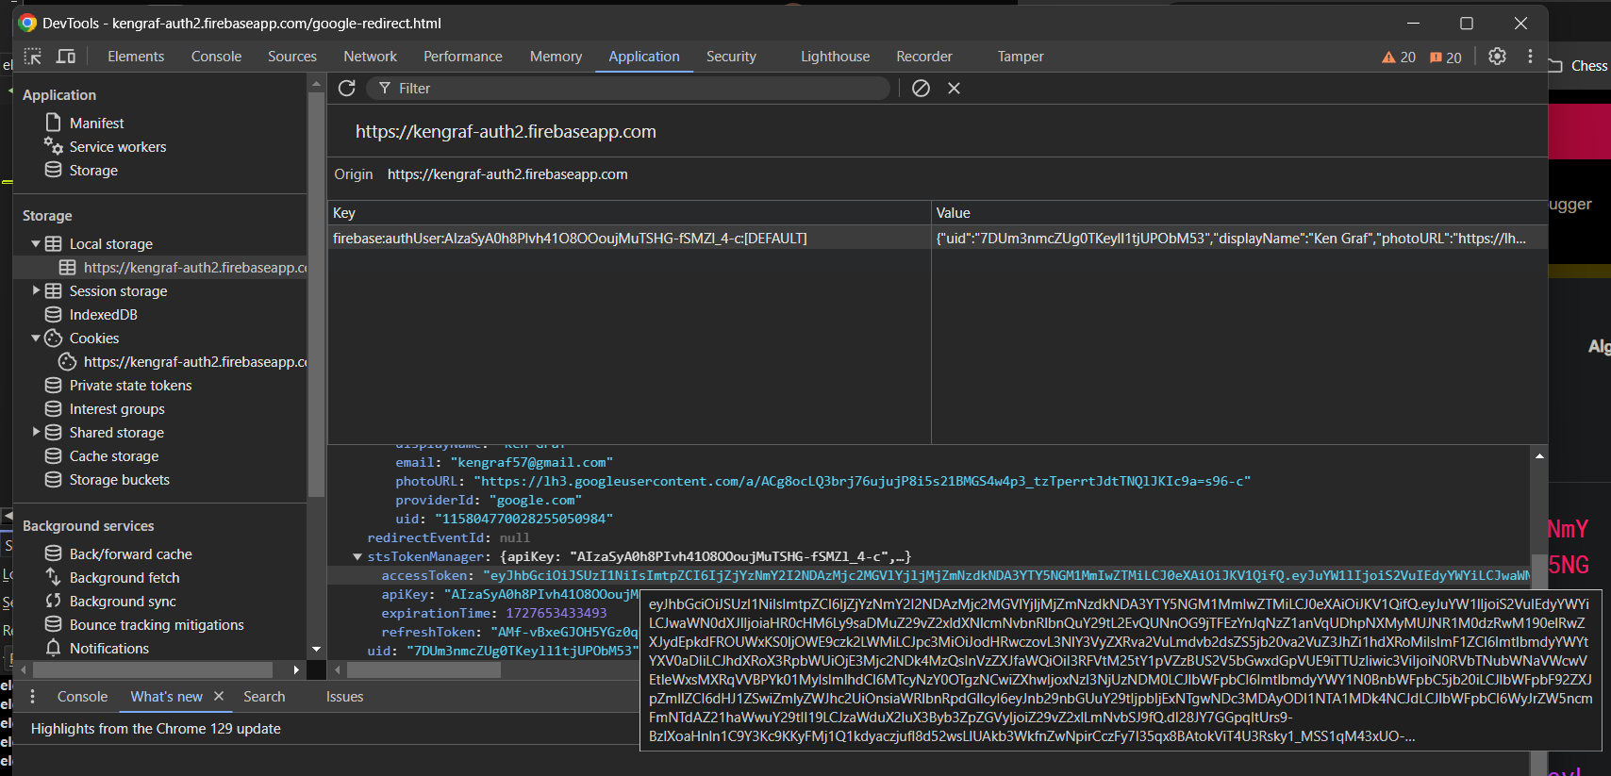
Or via Burp
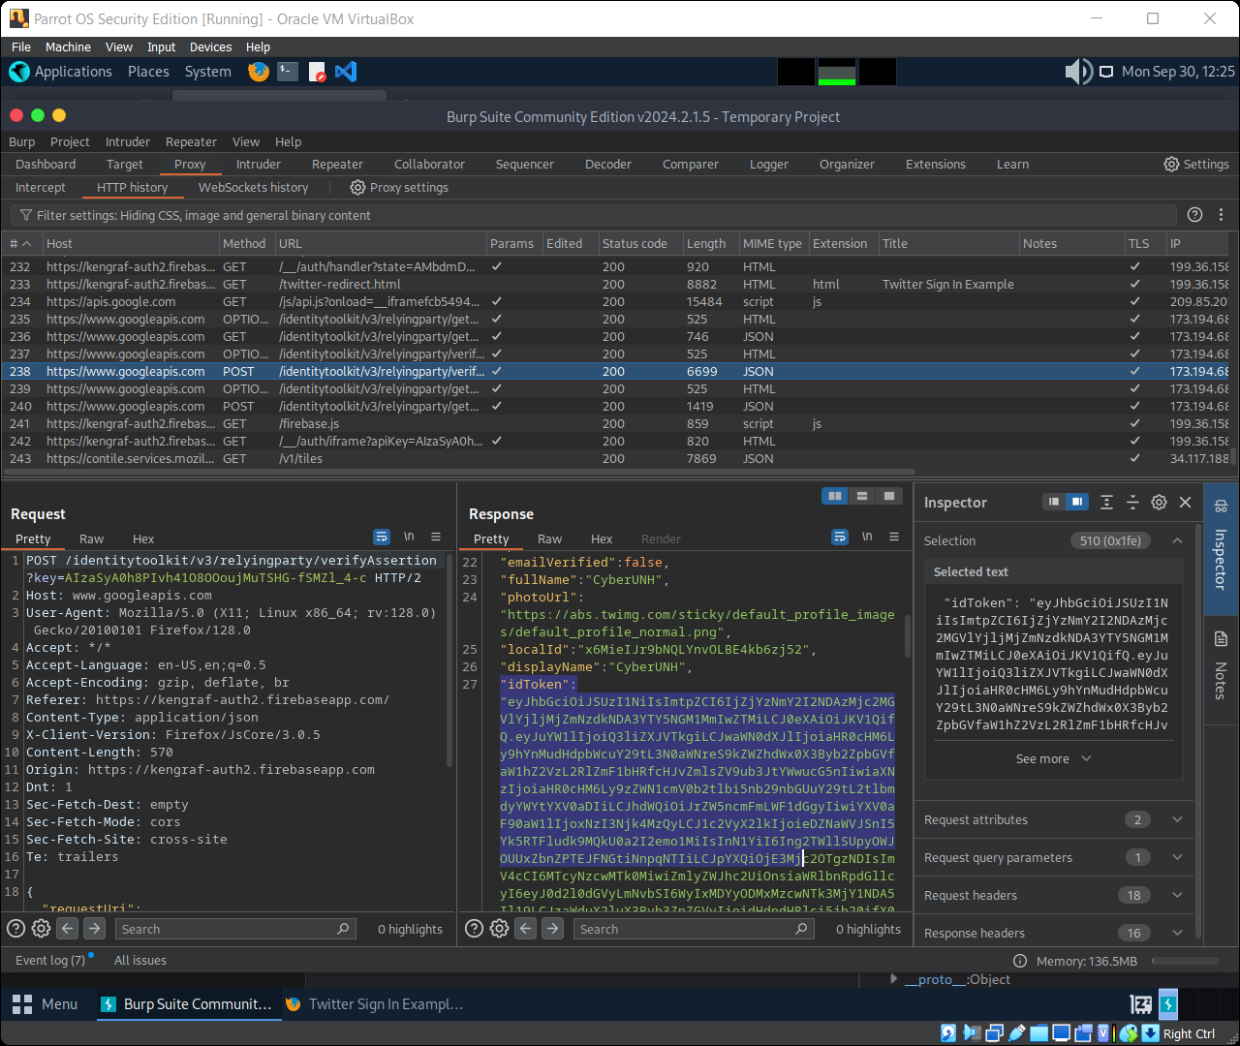
Review the access token
Cut and paste your accessToken in to the online JWT decoder here. The signature
will not validate because the key material is not part of the JWT.
Capture screenshots of a successful login and the output from decoding the accessToken.
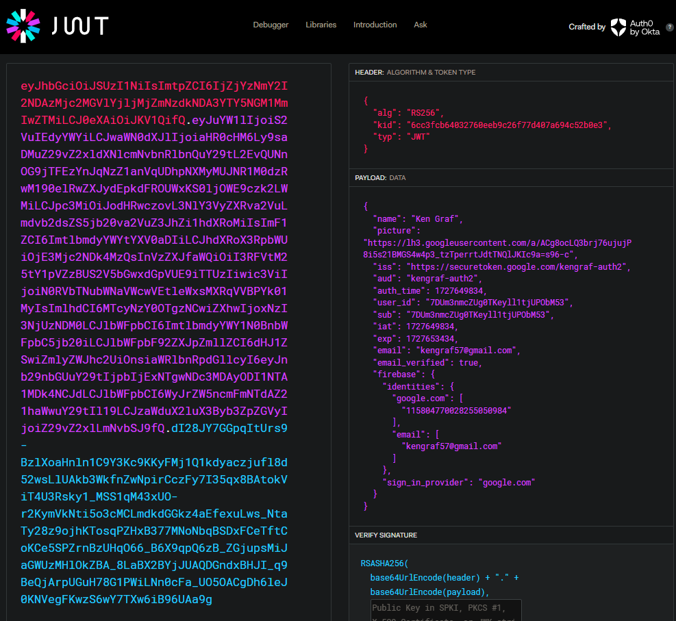
Tips/Questions:
Why do some sites require a real email address as the user name?
Were there additional headers in the browser response not shown on the web page?
What does a refresh token do?

