DNS Exfiltration

Summary
This lab shows how an attacker can exfiltrate data using DNS requests.
It is effective because firewalls typically do not block or even monitor outbound DNS requests.

Tools/Resources
Parrot: Python3, nslookup

Walkthrough
- Review code on Github: https://github.com/kengraf/DNSexfil/edit/main/dns_exfil_server.py
  - What port does it run on? 53
  - What functions are called? handler
  - Does it use any libraries? io, re, struct, socketserver, base64
  - Does it call any external services? No
  - What is the structure of the DNS request? First (least significant) subdomain is base64 encoded and the only part acted upon.
- Download program: curl https://raw.githubusercontent.com/kengraf/DNSexfil/main/dns_exfil_server.py > dns-exfil.py
- sudo python3 dns-exfil.py
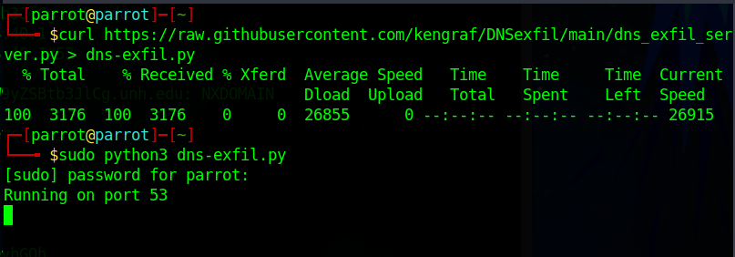
- Build a base64 message to send
  - base64, add your message, Ctrl-D
  - Ignore any trailing equal signs (=)
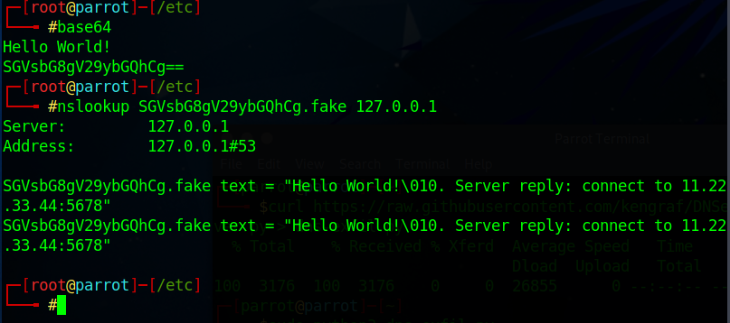
- Does the behavior change if we:
  - Try “unh.edu” as the base domain?
  - Set unh.edu to localhost in /etc/hosts?

Submission
Upload to Canvas a docx or pdf containing a screenshot showing:
- Your DNS exfil server answering requests
- Using nslookup to make requests to your DNS exfil server
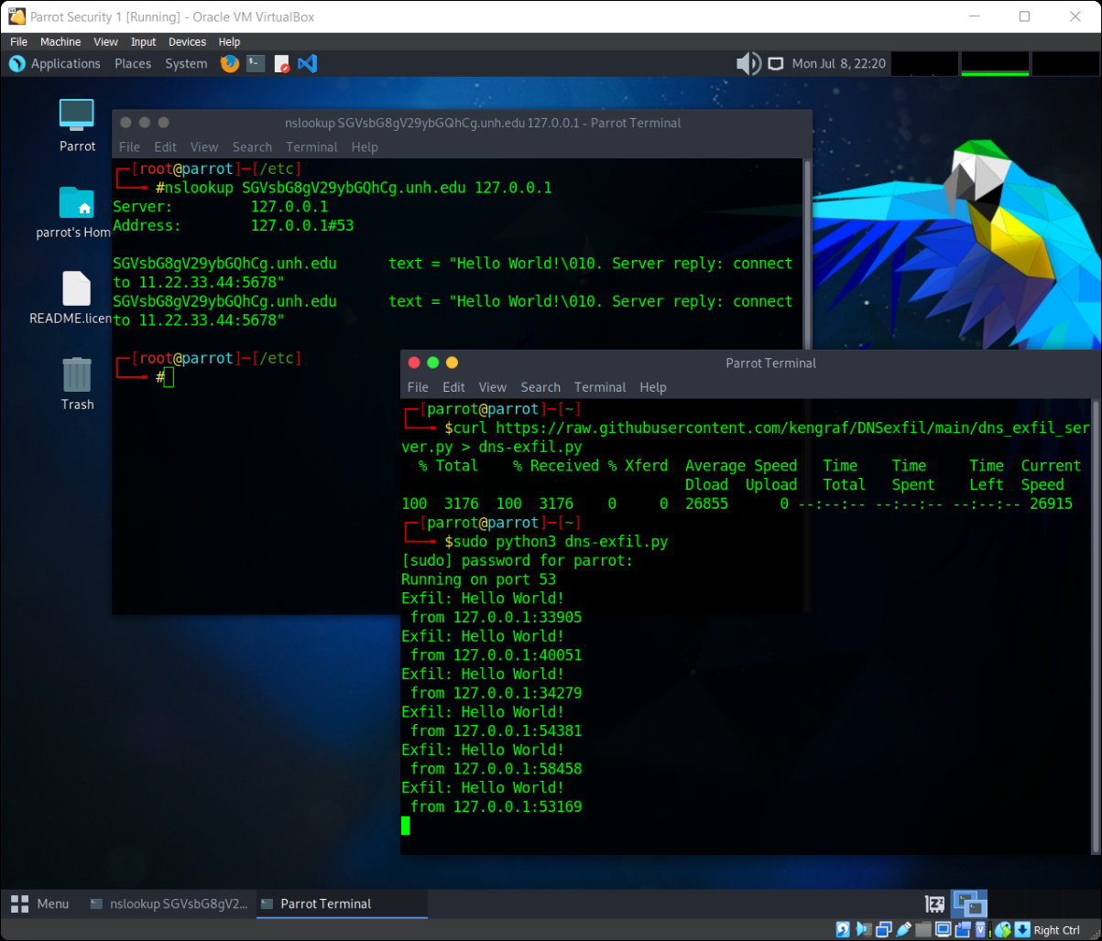

Additional Thoughts
How does an organization detect the exfiltration? One-offs would slide, repeated requests maybe not
How much data can be sent? 63 characters, base64 encoded = 378 bits
Could BOTs use this method to communicate with each other? Yes, but requests to unofficial DNS servers might standout.
Why does nslookup generate 2 requests? IPv4 and IPv6
How does this attack impact orgs that run internal DNS servers? Firewalls see the request coming from the internal DNS server not th machine that made the request.

