Docker

Summary
This lab introduces running basic Docker commands and running the OWASP Threat Dragon container. To do you will run a interactive Ubuntu container. Those new to Docker might find this resource helpful: https://training.play-with-docker.com/beginner-linux/

Tools
Parrot: Docker
Websites:
https://hub.docker.com/
https://labs.play-with-docker.com/

Tasks
- Configure docker.io as an apporved repo
- Configure the Threat Dragon environment
- Run Threat Dragon container
  - Show screenshot of docker command and timestamp
- Show Threat Dragon home page

Submission
Upload to Canvas a pdf or docx with two screenshots

Walkthrough
- Configure environment
# Add following line to /etc/containers/registries.conf
unqualified-search-registries = ["docker.io"]

- Not part of assignment but you run some practice docker commands for the class. And/or show: https://training.play-with-docker.com/beginner-linux/
docker container run --interactive --tty --rm ubuntu bash
docker container ls --all
docker ps -a

Pull, run, modify, list, kill HelloWorld from dockerhub.com (some exemples)
docker pull hello-world
docker run hello-world
docker container prune

- Configure environment for Threat Dragon
cat <<EOF >.env
NODE_ENV=development
ENCRYPTION_KEYS='[{"isPrimary": true, "id": 0, "value": "deadbeef2233445566778899aabbccdd"}]'
ENCRYPTION_JWT_SIGNING_KEY=deadbeef112233445566778899aabbcc
ENCRYPTION_JWT_REFRESH_SIGNING_KEY=deadbeef00112233445566778899aabb
SERVER_API_PROTOCOL='http'
EOF

- Run Threat Dragon container

docker run -d -p 8080:3000 -v $(pwd)/.env:/app/.env owasp/threat-dragon:stable
docker container ls --all

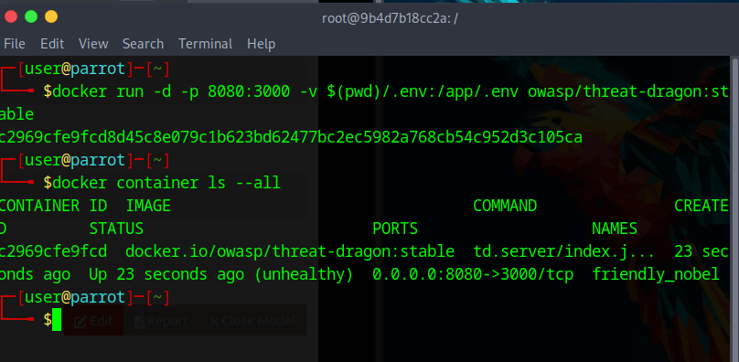
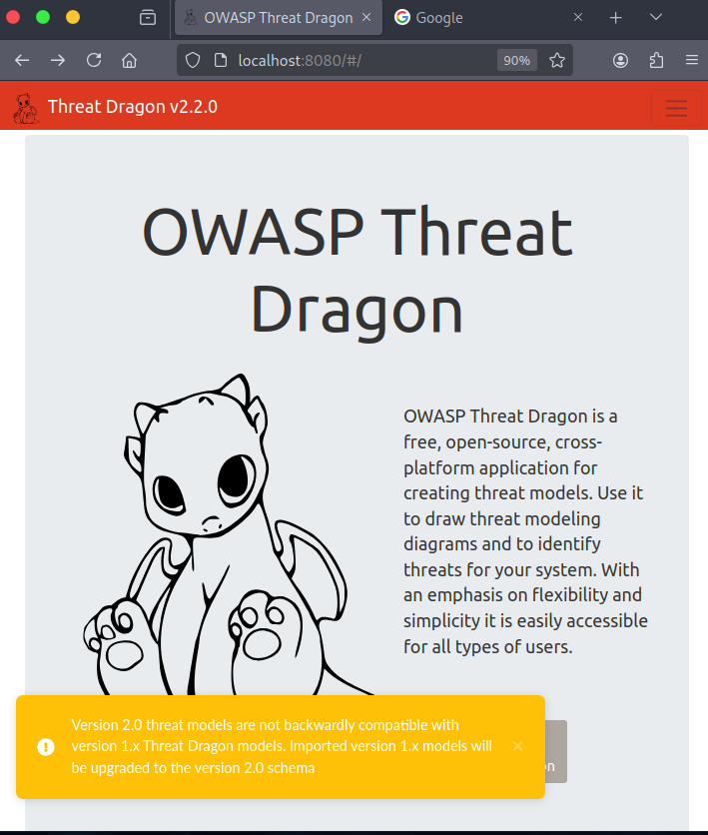

- Clean up Docker containers
docker ps -a -q
docker stop $(docker ps -a -q)
docker rm $(docker ps -a -q)

- Submit screenshots of terminal and ThreatDragon main page.

Additional Thoughts
How many containers can be associated with a single image?
How many images can be associated with a single container?
A good docker cheatsheet?
Docker swarm or Kubernetes?

