Parrot OS

Summary
This lab ensures everyone has the best tools and services needed to be successful this semester.
- Parrot OS provides many of the tools needed for this semester
- An account on AWS (or the cloud service of your choice)
- A domain name you have ownership

Tools/Resources
Parrot OS runs on a number of virtual and cloud environments. In past semesters students have had the most success running Parrot in a virtual environment on their laptop. VirtualBox is free. Parallels has been preferred by Apple users. Cloud deployments are how actual hackers would build their environment, but this comes with a cost.
Labs assume Parrot OS running on VirtualBox.

Walkthrough
- Install VirtualBox: link
- Download Parrot: link You need the virtual security version (AMD64|ARM64) version. The download has a “.OVA” extension
- Add Parrot as a new appliance. 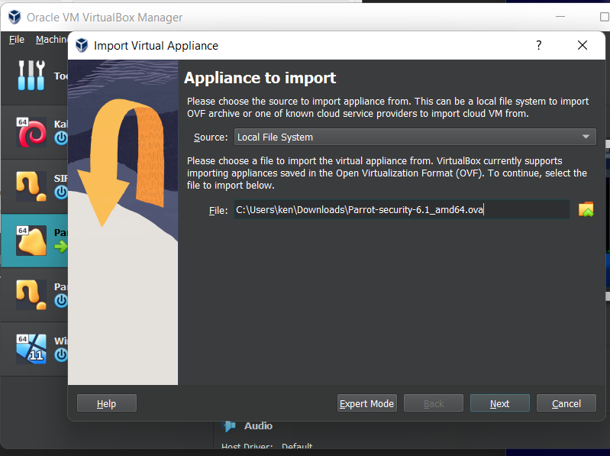
- Start Parrot. The default credentials for Parrot are: user=parrot password=parrot
You will be asked to update. Say yes (4-5 minutes). Stop Parrot and retart.

- Run the following commands for the latest upgrades. Parrot asks on install, so nothing will be added.
sudo apt-get update
sudo apt-get upgrade
- Optionally, to enable shared folders:
sudo adduser user vboxsf
sudo apt install virtualbox-guest-utils
sudo apt install virtualbox-guest-x11
sudo reboot
- Optional: Create a folder share between Parrot and your host OS.

Submission
Upload to Canvas a docx or pdf containing a screenshot showing in Parrot OS
- A browser windows accessing https://pi.kengraf.com
- A command window showing the end result of the apt-get upgrade command
