STRIDE threat modeling

Summary
This lab uses the OWASP’s ThreatDargon to model threats based on Microsoft’s STRIDE framework.

Tools/Resources
Parrot, Docker, ThreatDragon

Walkthrough
- The configuration of docker and running of the ThreatDragon container were covered by the previous lab.
- Pull and run ThreatDragon
docker run -d -p 8080:3000 -v $(pwd)/.env:/app/.env owasp/threat-dragon:stable
- In a browser visit the locally hosted ThreatDragon
http://localhost:8080/

- Login, Explore existing Threat Model, Version2 Demo Model, click around to review elements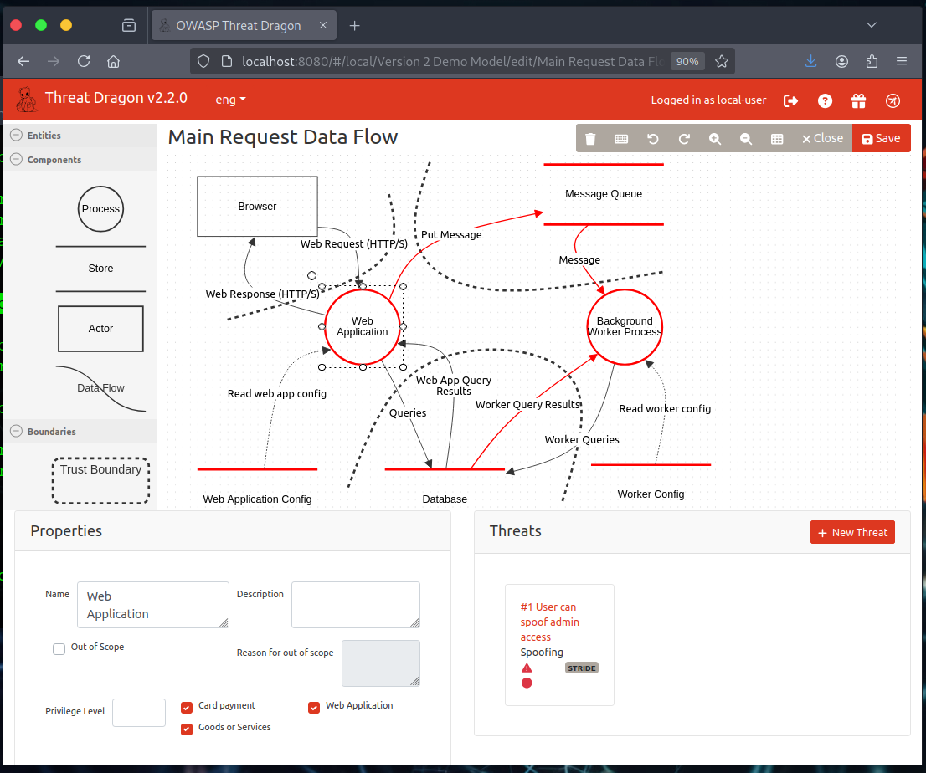
- Red elements are in scope.
  - Select the “Web Application” element.
  - Check in scope
  - For each STRIDE threat type create one new threat.
- Save your threat model “<your-email-id>.json”

Submission
Upload to Canvas your saved threat model “<your-email-id>.json”

Additional Thoughts
How often do multiple elements share the same threat?
How do the STRIDE threats types map to the OWASP top 10 risks?

