The Onion Router (TOR)

Summary

Investigate how The Onion Router (TOR) works and navigation of the Dark Web.

Tools/Resources
Parrot: TOR browser. Alternatives include AnonSurf and the tor command line tools.

Tasks
- Open the TOR browser and connect to TOR.
- Show your current TOR circuit.
- Capture screenshots for the following in the TOR browser
  - Visit the CIA’s Onion site
  - Visit the New York Times Onion site
  - Visit http://libertymutual.comLinks to an external site.
  - Visit Onion site of your choice

Submission
Submit your screenshots (PDF/DOCX) to Canvas for grading.

Walkthrough
- Open the TOR browser and connect to TOR.
- Show your current TOR circuit. Icon to left of lock icon.
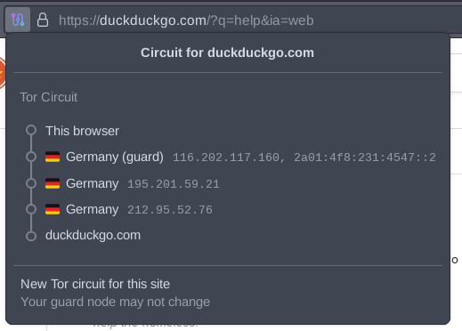
- Visit the CIA’s onion site
ciadotgov4sjwlzihbbgxnqg3xiyrg7so2r2o3lt5wz5ypk4sxyjstad.onion
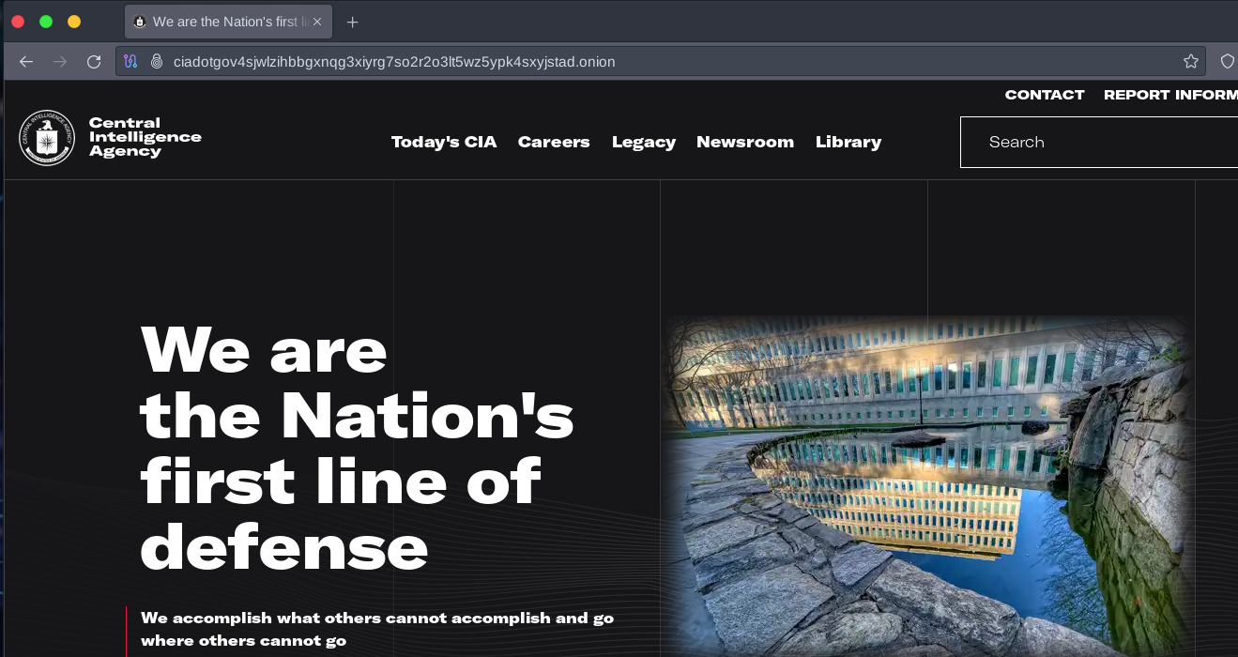
- Visit the New York Times Onion site
nytimesn7cgmftshazwhfgzm37qxb44r64ytbb2dj3x62d2lljsciiyd.onion

- Visit http://libertymutual.com
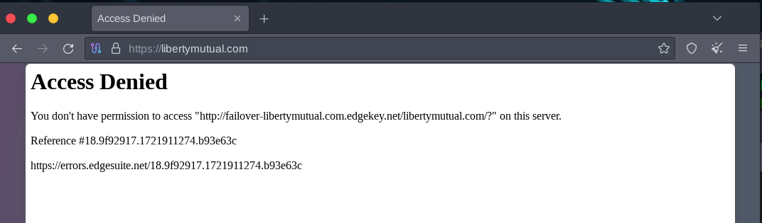
- Visit Onion site of your choice
Some suggestions here: https://www.expressvpn.com/blog/best-onion-sites-on-dark-web/

Submission
Upload to Canvas a docx or pdf containing a screenshot showing

Additional Thoughts
Why does Liberty Mutual block TOR? 1) TOR is a significant source of web attacks. 2) Not interested in doing business that what to be anonymous.
How can someone block TOR? Exit nodes are known. Blacklists for firewalls are available.
The TOR command line tools: A good writeup on installing (not needed with Parrot) and running the tools can be found here: https://linuxconfig.org/install-tor-proxy-on-ubuntu-20-04-linux. AnonSurf is another alternative.

